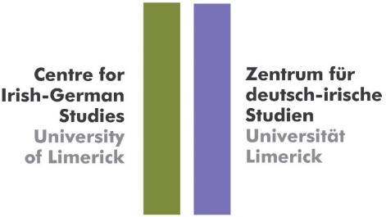
“Exploring the Many Facets of Irish-German Relations”
Centre for Irish-German Studies, University of Limerick
Activities 2019/20 – Spring semester 2020
Everyone is welcome to all of the events listed below
In his address to participants of the first event commemorating 90 years of diplomatic relations between Germany and Ireland in the Irish Embassy in Berlin in June 2019, Simon Coveney T.D., Minister for Foreign Affairs and Trade said: “Germany today is of vital importance to Ireland. One of our biggest trading partners, inward investment, investors and sources of tourism. And politically we have never been closer as we together protect and advance the interests of the European Union. In short, partners and friends more so today than at any other time in our history. So, as we mark 90 years of our official bilateral relationship, we are determined, both Germany and Ireland, to build on what we have already achieved.” https://issuu.com/centreforirish-germanstudies/docs/text_of_t_naiste_coveney (18 June 2019). Taking our cue from his words, we at the Centre for Irish-German Studies also want to build on the considerable work we have done so far and continue to explore many of the facets of Irish-German relations for the benefit of students and the interested general public - and show the relevance of these connections.
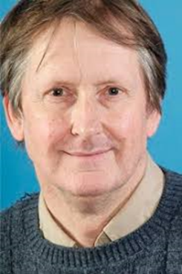
24 February 2020 – East German support for the struggle against apartheid, 1955-1989 – Lecture by Prof Tom Lodge, UL
Time and venue: 5pm in C1079, UL
The GDR was the first administration to offer support to South African political organisations opposing Apartheid. Tom Lodge, Professor of Peace and Conflict Studies in the Department of Politics and Public Administration, will look at reasons, impact, significance and effects of this support.

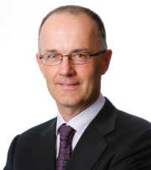
27 February 2020 – The need of foreign languages in the Irish economy – Lecture by Liam Ryan, CEO of SAP Ireland
Time and venue: 3pm in SG20, UL
Liam Ryan is SAP Labs Ireland managing director and winner of Great Places to Work’s Most Trusted Leader of 2016. SAP was founded in Germany in 1972 and came to Ireland over 20 years ago. It has offices in Dublin and Galway and employs close to 2,300 people across 41 lines of business.

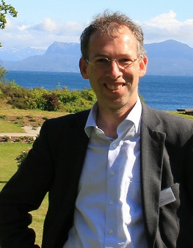
27 February 2020 – Portraits by the Artist as Memory fictions: Florian Henckel von Donnersmarck's film "Never Look Away" (2018) – Lecture by Prof. Dr. Michael Braun, Berlin
Time and venue: 4pm in C1079, UL
Prof. Dr. Michael Braun is Head of the Literature Department of the Konrad-Adenauer-Stiftung, Berlin. He will talk about Florian Henckel von Donnersmarck’s latest movie, Werk ohne Autor (Never Look Away) and its novel approach to dramatizing memory. Organised in coordination with the German Department at Mary Immaculate College.
2 March 2020 – Reading by Renate Ahrens as part of Limericker Literaturgespräche plus workshops and discussions.
Time and venue: 4pm in ERB007, UL
Renate Ahrens is a very prolific and versatile German writer. Having lived in Dublin for over 30 years she has recently returned to Hamburg. Many of her novels contain Irish-German elements. She will be reading from her latest novel Der andere Himmel (published October 2019). Her reading is supported by the DAAD writer-in-residence scheme and takes place in coordination with NUIG and UCD.
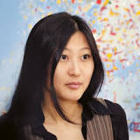
14 April 2020 Reading by Anna Kim
Time and venue: 10am C1061, UL
Korean-Austrian writer Anna Kim was Austria's winner of the European Union Prize for Literature in 2012. She has published poetry and three novels. She will read from her 2017 novel Die große Heimkehr. Organised in conjunction with the Austrian Embassy.
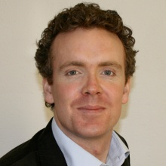
16 April 2020 Reporting from Germany – Lecture by Derek Scally (Berlin)
Time and venue: 3pm SG20, UL
Derek Scally, the long-time Irish Times Berlin correspondent, will give a lecture on the challenges journalists face today, time in Berlin and the importance of language learning. His experiences of reporting from Germany for more than a decade has given him unique insights into national and European politics.
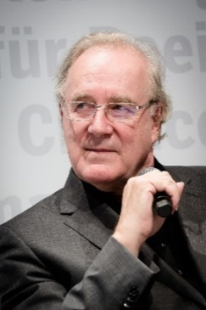
20 April 2020 – Reading by Sten Nadolny (Berlin) Das Glück des Zauberers (2017), part of Limericker Literaturgespräche
Time and venue: 3pm ERB007, UL
Sten Nadolny (Berlin) is one of the best-known German authors since the publication of Die Entdeckung der Langsamkeit (1983), selected as one of the “100 must reads” of German literature in the 20th century. Nadolny will read from his latest novel, Das Glück des Zauberers which shows that he still manages to enchant reviewers and readers alike.

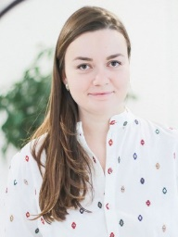
21/22 April 2020 War poetry by British and Irish women – Lecture by Sonya Permiakova (Centre for British Studies, HU Berlin), part of CBS & CIGS “Encounters and Exchange” Initiative
Time and venue: tbc, UL
Sonya Permiakova is a lecturer at the Centre for British Studies at the Humboldt-Universität Berlin. She will present aspects of her PhD project on war poetry. The lecture will be of interest to anyone working on English and Irish literature and history.
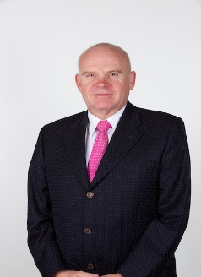
23 April 2020 – Economic links Ireland and Germany – Lecture by Ralf Lissek, Head of the German-Irish Chamber of Industry and Commerce (Dublin)
Time and venue: 3pm SG20, UL
Ralf Lissek has been CEO of the German-Irish Chamber of Industry and Commerce for many years. Founded in 1980 in order to promote bilateral trade and investment between Germany and Ireland, the German-Irish Chamber of Industry and Commerce has become an Organisation whose 350 member companies from various industries benefit from the services and network.
ALL EVENTS ARE FREE OF CHARGE AND EVERYONE IS WELCOME!
Please also check out activities of our partners: European Expo 2020 – Europe in Limerick https://www.limerick.ie/discover/whats-on/festivals/european-expo-2020
Maybe also of interest: 2020 Business German in Ireland Working Group Colloquium (BuGI), Dublin, 6 March 2020 &
Conference: “Lives and Legacies: Lesser-known Figures in Irish-German Relations”, UCC, 12-13 March 2020.

PAST Events of the Autumn Semester 2019/2020 (for more detailed descriptions of the events see our October newsletter)

20 September 2019 Reading by Hugo Hamilton
Time & venue: 11am, KB118, UL
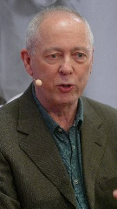
Hugo Hamilton is the best-known Irish-German writer. His memoir Speckled People (2003) (about his childhood growing up in a family with a German mother and an Irish nationalist father) has been a huge success and was translated into many languages. His new novel Dublin Palms (2019), already highly critically acclaimed, is in some ways a continuation of his memoir. His reading from Dublin Palms and the subsequent discussion with students of both memoirs was a booked out event and

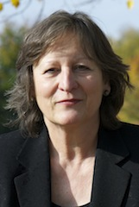
8 October 2019 Reading by Gabrielle Alioth & Fred Kurer (part of Limericker Literaturgespräche)
Time and venue: 11am ERB007, UL
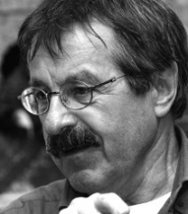
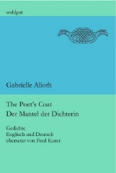
Swiss-Irish writer Gabrielle Alioth returned to UL on 8 October and together with Fred Kurer (St. Gallen) to read from her book The Poet's Coat / Der Mantel der Dichterin (Frauenfeld: Waldgut 2019). In contrast to Alioth’s novels written in German, the original language of her poems in this collection is English. For the bilingual edition the texts have been translated into German by Swiss Anglist, author and poet Fred Kurer.
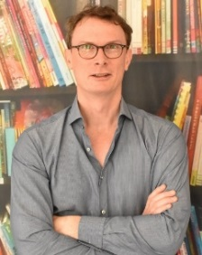
9 October 2019 Dr Sam McIntosh - Guest lecture
Time and venue: 4pm C1079 (Kate O’Brien Room)
Dr Sam McIntosh (HU, Berlin) gave a lecture on “The outsourcing and off-shoring of border control: state responsibility and a legal obligation to investigate deaths beyond borders” in the context of a newly developed cooperation project between the Centre for British Studies at the Humboldt-Universität Berlin, and CIGS entitled “Encounters and Exchange”. The event was chaired by Prof. Tom Lodge, Dept of Politics and Public Administration.

10 October 2019 Operation Shamrock - Roundtable Discussion and Exhibition
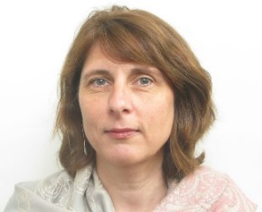
Time and venue: 4-6pm Appellate Court, Glucksman Library
German Ambassador H.E. Deike Potzel opened the Operation Shamrock exhibition and the event continued with a panel discussion with two participants of Operation Shamrock, Klaus Armstrong-Braun and Friedhelm Krüll as well as with the curator of the exhibition, Monica Brandis. The lively discussion to which also members of Friedhelm’s Irish family contributed was chaired by Dr Jérôme aan de Wiel (UCC).

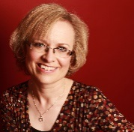
29 October 2019 Seán O’Casey and his Reception in the GDR - Lecture by Dr Deirdre Byrnes, NUI Galway
Time and venue: 10am ERB007, UL
Deirdre Byrnes, Senior Lecturer in German in NUI Galway, is co-editor of the recently published Perceptions and Perspectives – Exploring Connections between Ireland and the GDR (WVT: Trier, 2019).

14 November 2019 – International Colloquium “90th Anniversary of the Establishment of Diplomatic Relations – 1929-2019” Part 2 (Part 1 took place at the Irish Embassy in Berlin in June 2019 and was organised by the Centre for Irish-German Studies in collaboration with the Irish Embassy)
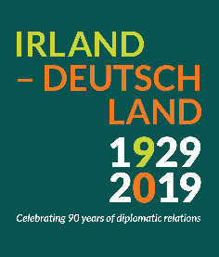
Time and venue: 2.30 - 6.30pm Appellate Court, Glucksman Library
A review of the history of Irish-German diplomatic relations and a discussion on current and future developments in bilateral diplomacy with current and former German and Irish diplomats, together with the Austrian and Swiss ambassador. For the full programme and more information please see: http://ulsites.ul.ie/irishgerman/upcoming-events.

PREVIEW
UPCOMING 2020/2021 - Autumn 2020

Irish-German Encounters - Lecture by Dr Claire O’Reilly (UCC)
Dr Claire O’Reilly was the first PhD student in Irish-German Studies at UL and has been lecturing in the German Department in UCC since 2005. She was Assistant Professor (Juniorprofessur) in Intercultural Training and International Relations at Chemnitz University of Technology from 2002 to 2005. She is co-editor with Veronica O’Regan (UL) of Ireland and the Irish in Germany - Reception and Perception published by Nomos (2014).

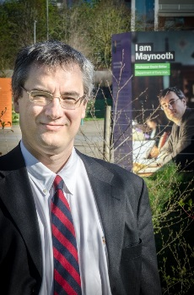
Mid October 2020 - German-speaking academics in Celtic Studies – Prof David Stifter (NUIM)
Prof David Stifter is Professor of Old Irish at Maynooth University and works on language variation and change in Old Irish, comparative Celtic linguistics (esp. Old Irish and Continental Celtic), language contact in the ancient world and on the early medieval British Isles. He will talk about the German, Austrian and Swiss academics who played an important role in the establishment of Celtic Studies.

The support of the German Academic Exchange Service (DAAD), the School of English, Irish and Communication, the Europe Initiative, the Glucksman Library, the Goethe Institut, the School of Law, the School of Modern Languages and Applied Linguistics, the AHSS Teaching Fund, the Dr Schuler Fund, the Austrian, German and Swiss Embassies in Dublin and the Irish Embassy in Berlin is gratefully acknowledged.

For more information please contact Dr Gisela Holfter, Director, Centre for Irish-German Studies, University of Limerick: +353-202395 or Gisela.Holfter@ul.ie.

