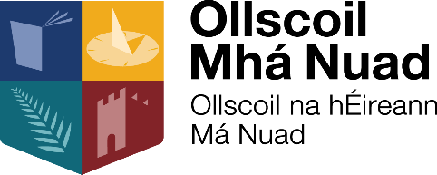

Lárionad na Gaeilge: Taighde, Teagasc agus Tástáil
Centre for Irish Language: Research, Teaching and Testing

A high-level delegation from the European Parliament in Luxembourg will visit Maynooth University in the morning of the 24 March 2020 with a view to promoting Irish linguist profiles at the Parliament and discussing the translation profession with both university academics and students. The delegation will include Valter Mavrič, Director General for Translation at the European Parliament, Véronique Rosenkranz, Director for Translation, and Ieva Mainardi, Head of the Irish-language Unit.

The group has asked to meet members of the management team and lecturers for the first half hour, followed by a bilingual presentation (Irish and English) for students and a question and answer session; the latter should take about 1 ½ hours. The delegation will return to Luxemburg later that day.

Although the Parliament in Luxemburg will no longer recruit ‘translators’ but ‘intercultural and language professionals’, the work of new recruits will still focus on translation.

The delegation would like to meet students studying translation, Irish, French, German, Italian, Spanish and, in particular, law. The European institutions are especially interested in Irish applicants with English skills, since, as a result of Brexit, UK citizens will no longer be recruited.

Students from other universities will also be welcome to attend the presentation, as the delegation will not be in a position to visit any other institution in the Dublin area on this occasion.

Venue: Room 2.33, Iontas Building, North Campus, Maynooth University
Time: 10.00
Registration: Please confirm attendance at the following address: larionad.gaeilge@mu.ie

